CSIS1175 W17 programming project 10% of course grade

In this programming project, you are required to work with at least another student (max 3 including yourself) to create a program that will provide a Skytrain (Expo Line, Canada Line, Millennium Line, and Evergreen Extension) schedule to the users. Below is the basic design of the screen. You are allowed to modify it to make it more professional looking. Since it may take you a while to figure out the logics, you must start working on this project now.

This project examines your skill in logical thinking, array and file processing. There is not much math involved except counting the number of stations travelled in order to determine the best route for the journey. Douglas College policy on academic integrity will be enforced.

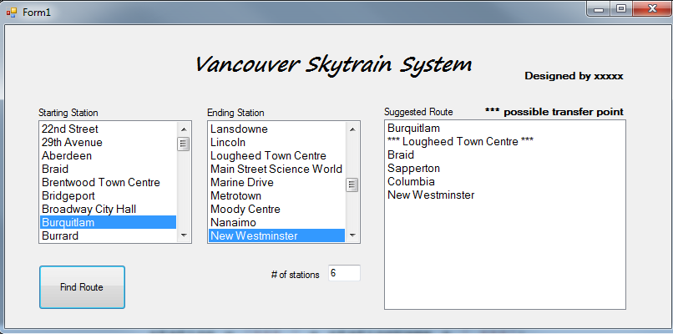

Your program lets the user select both the start and ending stations from the corresponding listboxes. After the selections, the user will click on the Find Route button. Your program will then determine the shortest route for the journey. You should realize that there may be multiple routes between two points. For example, to travel from New West to Holdom, you can go either east (Columbia) and then travel on the upper loop or west (22nd street) on the lower loop. For simplicity sake, your program uses the number of stations (including the starting and ending points) travelled to determine the shortest route.

The shortest route will be displayed on a listbox, similar to the one shown on the right above.

You should note that user needs not to spell out the station names at all. He/she simply selects them from the lists.

If you have to use input files for this project, your files must be stored and access on c:\temp.

To submit your project, you must do the following:

Provide a one-page instruction on showing user how to use your program

Provide the necessary data files as part of the attachment in your submission

Save you entire project (name to be decided later), data files, and the instruction on a usb drive for submission in class.

Due date March 21 2017 for section 002, March 22 2017 for section 009.

No late submission will be accepted.